Lab 1 – ASR Lab 1 Static Routes Revision

Topology
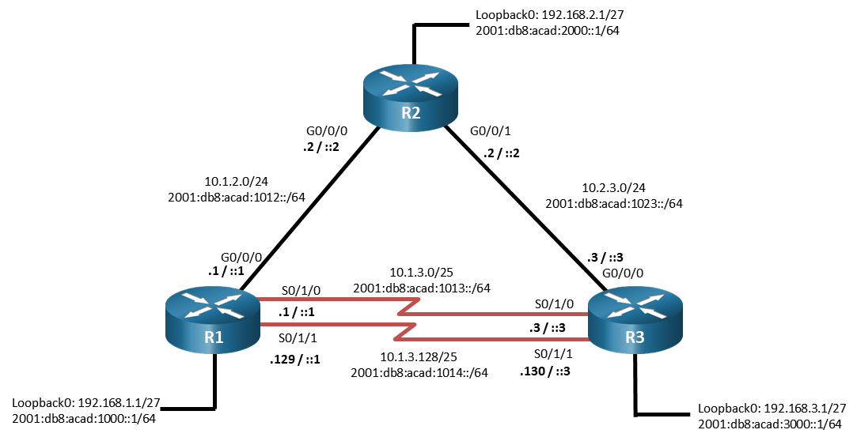

Addressing Table
Device | Interface | IPv4 Address | IPv6 Address | IPv6 Link-Local
R1 | G0/0/0 | 10.1.2.1/24 | 2001:db8:acad:1012::1/64 | fe80::1:1
R1 | S0/1/0 | 10.1.3.1/25 | 2001:db8:acad:1013::1/64 | fe80::1:2
R1 | S0/1/1 | 10.1.3.129/25 | 2001:db8:acad:1014::1/64 | fe80::1:3
R1 | Loopback0 | 192.168.1.1/27 | 2001:db8:acad:1000::1/64 | fe80::1:4
R2 | G0/0/0 | 10.1.2.2/24 | 2001:db8:acad:1012::2/64 | fe80::2:1
R2 | G0/0/1 | 10.2.3.2/24 | 2001:db8:acad:1023::2/64 | fe80::2:2
R2 | Loopback0 | 192.168.2.1/27 | 2001:db8:acad:2000::1/64 | fe80::2:3
R3 | G0/0/0 | 10.2.3.3/24 | 2001:db8:acad:1023::3/64 | fe80::3:1
R3 | S0/1/0 | 10.1.3.3/25 | 2001:db8:acad:1013::3/64 | fe80::3:2
R3 | S0/1/1 | 10.1.3.130/25 | 2001:db8:acad:1014::3/64 | fe80::3:3
R3 | Loopback0 | 192.168.3.1/27 | 2001:db8:acad:3000::1/64 | fe80::3:4

Objectives
Part 1: Configure and Investigate IPv4 Static Routes
Part 2: Configure and Investigate IPv6 Static Routes
Part 3: Complete Static Routing Challenge

Background / Scenario
There are several different types of static routes available for you to use. You should fully understand the implications of each type of static route on the routing table and the overall routing scheme in the network. In this lab, you will configure several different types of static routes for both IPv4 and IPv6 and examine the impact of the static route on the routing table and traffic flow in the network.

Instructions
Close configuration window

Configure and Investigate IPv4 Static Routes
In Part 1, you will configure and investigate various types of static routes. For this part of the lab, all of your work will be on R1.

On R1, configure a directly attached static route.
      - Verify the interface status across all 3 routers. Look at both IPv4 and IPv6 addressing.
      - Create a directly attached static route for the 192.168.2.0/27 network using G0/0/0 as the exit interface.
      - Issue the command show ip route static and examine the output. As long as interface GigabitEthernet0/0/0 is up and operational, this entry will be present in the routing table. Note that the output does not give you indication of the Administrative Distance or Metric for this route.
R1# show ip route static
Gateway of last resort is not set

192.168.2.0/27 is subnetted, 1 subnets
S 192.168.2.0 is directly connected, GigabitEthernet0/0/0
      - To get details on the route, issue the command show ip route 192.168.2.0 255.255.255.224. This output provides the Administrative Distance and Metric for the route. An AD of 1 is the default for static routes and is the second most trusted AD available.
R1# show ip route 192.168.2.0 255.255.255.224
Routing entry for 192.168.2.0/27
Known via "static", distance 1, metric 0 (connected)
Routing Descriptor Blocks:
* directly connected, via GigabitEthernet0/0/0
Route metric is 0, traffic share count is 1

On R1, configure a recursive static route.
Every route lookup must resolve to an exit interface. When the route for a destination is configured with an IP address as its next-hop, the router has to determine what exit interface to use to get to that next-hop, which causes a recursive lookup. A recursive route is one that requires an additional lookup in the routing table.
Cisco Express Forwarding (CEF), which is enabled by default, automatically works through the iterative process of finding the exit interface so the CPU is not involved in that process for each packet matching the recursive route. This helps reduce latency and CPU load.
Note: A recursive static route cannot depend upon a default static route for next-hop resolution. The router must have a valid route to the intermediary network or the recursive static route will not be inserted into the routing table.
      - On R1, configure a recursive static route for the 10.2.3.0/24 network using the next hop address 10.1.2.2.
      - Issue the command show ip route static and examine the output. Notice the entry for 10.2.3.0/24 does not list an exit interface. This indicates that a recursive lookup is necessary.
R1# show ip route static
Gateway of last resort is not set

10.0.0.0/8 is variably subnetted, 7 subnets, 3 masks
S 10.2.3.0/24 [1/0] via 10.1.2.2
192.168.2.0/27 is subnetted, 1 subnets
S 192.168.2.0 is directly connected, GigabitEthernet0/0/0
      - Issue the command show ip route 10.2.3.0 255.255.255.0 and examine the output. It shows all the information expected for a static route; an AD of 1 and a metric of 0. Once again, the output does not show a next hop address. Under non-CEF conditions, the router would have to do an additional route lookup to decide how to reach the next-hop address 10.1.2.2. The way around this is to create a fully specified static route.
R1# show ip route 10.2.3.0 255.255.255.0
Routing entry for 10.2.3.0/24
Known via "static", distance 1, metric 0
Routing Descriptor Blocks:
* 10.1.2.2
Route metric is 0, traffic share count is 1

On R1, Look at an example of a fully specified static route (will not work on the tool)
A fully specified static route is configured using both the exit interface specification and the next-hop IP address. The route is only valid if the exit interface is up. A fully specified static route is preferred so that recursive lookups do not result in routing decisions that might add latency to the path.
R1(config)# ip route 10.2.3.0 255.255.255.0 g0/0/0 10.1.2.2
R1(config)# end

On R1, configure a floating static route.
Floating static routes typically provide secondary or backup to a primary link. By default, static routes have an administrative distance (AD) of 1 and directly connected routes have an AD of zero. Directly connected routes are seen in the routing table with a code of “C” or “L” with the AD of 0 as shown below:
R1# show ip route 10.1.2.1
Routing entry for 10.1.2.1/32
Known via "connected", distance 0, metric 0 (connected)
Routing Descriptor Blocks:
* directly connected, via GigabitEthernet0/0/0
Route metric is 0, traffic share count is 1

R1# show ip route 10.1.2.0 255.255.255.0
Routing entry for 10.1.2.0/24
Known via "connected", distance 0, metric 0 (connected, via interface)
Routing Descriptor Blocks:
* directly connected, via GigabitEthernet0/0/0
Route metric is 0, traffic share count is 1
A floating static route is a static route that has been assigned a higher AD than the default. The classic use case for a floating static route is to provide a backup to a dynamic routing protocol. For example, the AD for OSPF is 110. As long as OSPF is working, destinations are reachable. But what if OSPF fails? Adding a floating static route with an AD of 112 would allow that route to be inserted into the routing table as soon as OSPF fails, and then be removed as soon as OSPF is restored. The key benefit to this is that traffic continues to flow.
For this example, we will consider the connections between R1 and R3. Normally, when there are multiple direct connections between two routers and those connections are included in routing, we can expect equal cost load balancing to occur. In this case, we are going to manually control which connection is used so that we can demonstrate a floating static route.
      - Configure a static route to the 192.168.3.0/27 network using the exit interface s0/1/0
      - Examine the routing table with the show ip route static command to ensure the route is in place.
R1# show ip route static
Gateway of last resort is not set

10.0.0.0/8 is variably subnetted, 7 subnets, 3 masks
S 10.2.3.0/24 [1/0] via 10.1.2.2, GigabitEthernet0/0/0
192.168.2.0/27 is subnetted, 1 subnets
S 192.168.2.0 is directly connected, GigabitEthernet0/0/0
192.168.3.0/27 is subnetted, 1 subnets
S 192.168.3.0 [1/0] via 10.1.3.3, Serial0/1/0
      - Configure another static route to the 192.168.3.0/27 network, but this time use the exit interface s0/1/1.
      - Examine the routing table with the show ip route static command and you will see that the router has adopted both routes as valid paths to the 192.168.3.0/27 network.
R1# show ip route static
Gateway of last resort is not set

10.0.0.0/8 is variably subnetted, 7 subnets, 3 masks
S 10.2.3.0/24 [1/0] via 10.1.2.2, GigabitEthernet0/0/0
192.168.2.0/27 is subnetted, 1 subnets
S 192.168.2.0 is directly connected, GigabitEthernet0/0/0
192.168.3.0/27 is subnetted, 1 subnets
S 192.168.3.0 is directly connected via Serial0/1/1
via Serial0/1/0
      - Look more closely at the route to the 192.168.3.0/27 network and you can verify how the router is going to load balance between the two paths. The traffic share count for each of the routes tells you the number of packets that will be sent using the referenced route. In this case, the s0/1/0 path will get one packet and then the s0/1/1 path will get one packet.

R1# show ip route 192.168.3.0 255.255.255.224
Routing entry for 192.168.3.0/27
Known via "static", distance 1, metric 0
Routing Descriptor Blocks:
10.1.3.130, via Serial0/1/1
Route metric is 0, traffic share count is 1
* 10.1.3.3, via Serial0/1/0
Route metric is 0, traffic share count is 1
      - Now you will adjust this so that the s0/1/1 path is a standby. You will do this by deleting the current route that uses s0/1/1 as an exit interface and adding in another static route via s0/1/1, this time adding an AD of 7.
      - Now examine the routing table with the show ip route static command, and you will see there is only one route to the 192.168.3.0/27 network in the routing table.
R1# show ip route static
Gateway of last resort is not set

10.0.0.0/8 is variably subnetted, 7 subnets, 3 masks
S 10.2.3.0/24 [1/0] via 10.1.2.2, GigabitEthernet0/0/0
192.168.2.0/27 is subnetted, 1 subnets
S 192.168.2.0 is directly connected, GigabitEthernet0/0/0
192.168.3.0/27 is subnetted, 1 subnets
S 192.168.3.0 [1/0] via 10.1.3.3, Serial0/1/0
      - The output of show ip route 192.168.3.0 255.255.255.224 only shows the s0/1/0 path as well.
R1# show ip route 192.168.3.0 255.255.255.224
Routing entry for 192.168.3.0/27
Known via "static", distance 1, metric 0
Routing Descriptor Blocks:
* 10.1.3.3, via Serial0/1/0
Route metric is 0, traffic share count is 1
      - Now issue the shutdown command on interface s0/1/0, then examine the routing table again. You will see that the route using s0/1/1 is in the routing table and operational, with the AD specified as 7.
R1# config t
Enter configuration commands, one per line. End with CNTL/Z.
R1(config)# interface s0/1/0
R1(config-if)# shutdown
R1(config-if)# end

R1# show ip route static | begin Gateway
Gateway of last resort is not set

10.0.0.0/8 is variably subnetted, 5 subnets, 3 masks
S 10.2.3.0/24 [1/0] via 10.1.2.2, GigabitEthernet0/0/0
192.168.2.0/27 is subnetted, 1 subnets
S 192.168.2.0 is directly connected, GigabitEthernet0/0/0
192.168.3.0/27 is subnetted, 1 subnets
S 192.168.3.0 [7/0] via 10.1.3.130, Serial0/1/1
      - Issue the command show ip route 192.168.3.0 255.255.255.0 and you will see the AD confirmed.
R1# show ip route 192.168.3.0 255.255.255.224
Routing entry for 192.168.3.0/27
Known via "static", distance 7, metric 0
Routing Descriptor Blocks:
* 10.1.3.130, via Serial0/1/1
Route metric is 0, traffic share count is 1
      - When s0/1/0 recovers, it is automatically placed into the routing table and the s0/1/1 path is removed. Issue the no shutdown command on interface s0/1/0, and then look at the routing table.
R1# config t
Enter configuration commands, one per line. End with CNTL/Z.
R1(config)# interface s0/1/0
R1(config-if)# no shutdown
R1(config-if)# end

R1# show ip route static | begin Gateway
Gateway of last resort is not set

10.0.0.0/8 is variably subnetted, 7 subnets, 3 masks
S 10.2.3.0/24 [1/0] via 10.1.2.2, GigabitEthernet0/0/0
192.168.2.0/27 is subnetted, 1 subnets
S 192.168.2.0 is directly connected, GigabitEthernet0/0/0
192.168.3.0/27 is subnetted, 1 subnets
S 192.168.3.0 [1/0] via 10.1.3.3, Serial0/1/0
Close configuration window

Configure and Investigate IPv6 Static Routes

On R3, configure a recursive static route.
      - Create a route to the 2001:db8:acad:1012::/64 network via 2001:db8:acad:1023::2.
Open configuration window
      - Issue the show ipv6 route static command and examine the static route in the routing table.
R3# show ipv6 route static
IPv6 Routing Table - default - 11 entries
Codes: C - Connected, L - Local, S - Static, U - Per-user Static route
<output omitted>

S 2001:DB8:ACAD:1012::/64 [1/0]
via 2001:DB8:ACAD:1023::2
      - Examine the route details with the command show ipv6 route 2001:db8:acad:1012::/64.
R3# show ipv6 route 2001:db8:acad:1012::/64
Routing entry for 2001:DB8:ACAD:1012::/64
Known via "static", distance 1, metric 0
Route count is 1/1, share count 0
Routing paths:
2001:DB8:ACAD:1023::2
Last updated 00:02:28 ago

On R3, configure a floating static route.
      - On R3, create a static route towards 2001:db8:acad:1000::/64 via the next hop 2001:db8:acad:1013::1
      - On R3, create another static route towards 2001:db8:acad:1000::/64 via the next hop 2001:db8:acad:1014::1 with an AD of 17.
      - Show the IPv6 routing table and confirm that the first route, exiting s0/1/0, is installed in the routing table.
R3# show ipv6 route static
IPv6 Routing Table - default - 12 entries
Codes: C - Connected, L - Local, S - Static, U - Per-user Static route
<output omitted>
S 2001:DB8:ACAD:1000::/64 [1/0]
via 2001:DB8:ACAD:1013::1, Serial0/1/0
S 2001:DB8:ACAD:1012::/64 [1/0]
via FE80::2:2, GigabitEthernet0/0/0
      - Shutdown interface s0/1/0 and then verify that the second route, via s0/1/1, is installed in the routing table.
R3# config t
Enter configuration commands, one per line. End with CNTL/Z.
R3(config)# interface s0/1/0
R3(config-if)# shutdown
R3(config-if)# end

R3# show ipv6 route static
IPv6 Routing Table - default - 10 entries
Codes: C - Connected, L - Local, S - Static, U - Per-user Static route
<output omitted>
S 2001:DB8:ACAD:1000::/64 [17/0]
via 2001:DB8:ACAD:1014::1, Serial0/1/1
S 2001:DB8:ACAD:1012::/64 [1/0]
via FE80::2:2, GigabitEthernet0/0/0
      - Issue the no shutdown command on R3 s0/1/0 and confirm that the first route is restored in the routing table.
R3# config t
Enter configuration commands, one per line. End with CNTL/Z.
R3(config)# interface s0/1/0
R3(config-if)# no shutdown
R3(config-if)# end

R3# show ipv6 route static
IPv6 Routing Table - default - 12 entries
Codes: C - Connected, L - Local, S - Static, U - Per-user Static route
<output omitted>
S 2001:DB8:ACAD:1000::/64 [1/0]
via 2001:DB8:ACAD:1013::1, Serial0/1/0
S 2001:DB8:ACAD:1012::/64 [1/0]
via FE80::2:2, GigabitEthernet0/0/0

On R3 Finish the last route.
      - On R3, create a static route towards 2001:db8:acad:2000::/64 via g0/0/0 towards R2.
      - Verify using show ipv6 route static
      - Activity should score as 57% at this point with 8 routes configured.
Close configuration window

Complete Static Routing Challenge
Through the course of this lab, we have installed and examined many different types of static route, both for IPv4 and IPv6. But we have not configured routing on all the routers, nor have we tested any of the routes.
For this part of the lab, your challenge is to configure R1 and R3 with static routes that provide full reachability in the network. R2 has already been configured and you’re welcome to check the routes on R2 and test connectivity to R2.
You can use extended ping to use the Loopback interfaces as sources, as shown below.
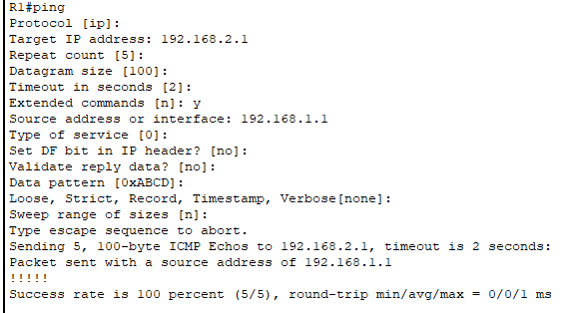
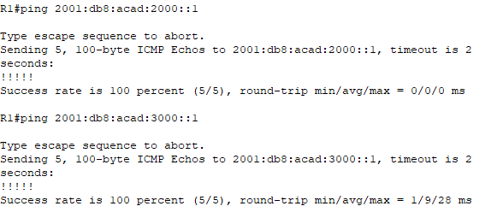
      - Configure the missing IPv6 routes on R1 and use exit interface (s0/1/0) for the route (acad:3000) attached to R3 and exit interface with link-local address for the other two routes accessible via R2.
      - Please configure the missing IPv4 routes on R3 using the appropriate next hop IP addresses. You must create a route to R1 Loopback using next hop IP for s0/1/0 only. Create a route to R2 LAN via R2 next hop and same for the link between R1 and R2.
      - Verify using appropriate show commands and ping.
      - There are 3 missing routes per router.
End of doc

